|  |
| --- |
|  |
| DTMF (Dual Tone Multi-Frequency)  Engr. Naina Said |
| |  |  |  | | --- | --- | --- | | MUHAMMAD ASIF AYUB Assad Ullah Khan | 2/3/20 | Digital Signal Processing | |

Contents

ABSTRACT 2

INTRODUCTION 2

ALGORITHM 3

DTMF IN COMMUNICATION 4

NEED OF DTMF DECODING 5

BLOCK DIAGRAM 6

DTMF GENERATION .7

DTMF DETECTION .8

FREQUENCY GENERATION .8

APPLICATION .9

RESULTS & CONCLUSION .10

REFERENCES 11

# abstract

# introductionabstract

# introduction

# Physiological Basisintroductionabstract

# introductionabstract

In telecommunication, a caller needs to dial the number of the person to which he/she wants to talk with. The earlier versions of telephones used to have rotary type dials which are now obsolete. Almost all the landline and mobile phone handsets now use pushbutton keypads as shown in the figure below:

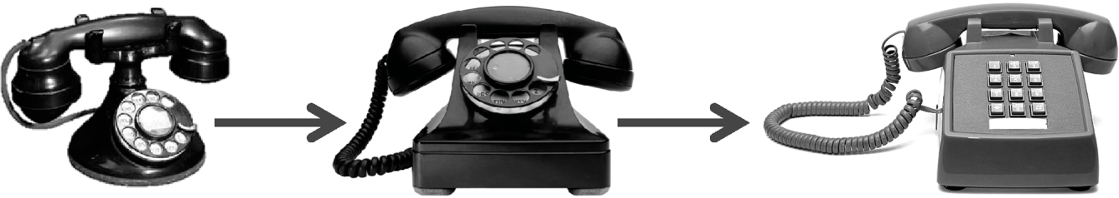

# introduction

# Physiological Basisintroduction

# Physiological Basis

# ECG FeaturesPhysiological Basisintroduction

# Physiological Basisintroduction

Before DTMF was created, telephone networks used a system called “Decadic”. This system was used extensively in telephone networks to dial numbers, it was very useful system, but limited to the local exchange connections requiring an operator to connect long distance calls. In the late years of 1950, DTMF was being developed for the purpose of allowing tone signals to dial long distance numbers, which could be potentially be dialed not only via standard wire networks, but also via radio links . The version of DTMF used for telephone tone dialing is known by the trademarked term “Touch-Tone”.

“DTMF is a signalling system for identifying the keys or better say the number dialled on a pushbutton or DTMF keypad”.

The early telephone systems used pulse dialling or loop disconnect signalling. This was replaced by multi frequency (MF) dialling. DTMF is a multi frequency tone dialling system used by the push button keypads in telephone and mobile sets to convey the number or key dialled by the caller. DTMF has enabled the long-distance signalling of dialled numbers in voice frequency range over telephone lines. This has eliminated the need of telecom operator between the caller and the next person to talk with and evolved automated dialling in the telephone switching centres.

DTMF (Dual tone multi frequency) as the name suggests uses a combination of two Sine wave tones to represent a key. These tones are called row and column frequencies as they correspond to the layout of a telephone keypad.

# Algorithm

# ECG FeaturesPhysiological Basis

# ECG Features

# Circuit DiagramECG FeaturesPhysiological Basis

# ECG FeaturesPhysiological Basis

* Generate a DTMF signal with 8 different combinations of frequency.
* DTMF signal is applied to the decoder
* FFT is applied to each signal.
* Comparing the FFT signal with look up tables.
* Get the information of which button is pressed.
* Connect the Dialer to the Receiver address obtained through decoder.

# dtmf in cummunication

# ECG FeaturesPhysiological Basis

# ECG Features

# Circuit DiagramECG FeaturesPhysiological Basis

# ECG FeaturesPhysiological Basis

There is always a possibility that a random sound will be on the similar frequency which will trip up the DTMF sounds system. It was recommended that if two tones were used to represent a digit, the probability of a false signal happening is ruled out, thus the name ‘Dual Tone’.

This is the basis of using dual tone in DTMF communication. DTMF dialing uses a keypad with 12 or 16 buttons. Each key pressed on the keypad generates two tones of particular frequencies, so a voice or a random signal cannot mimic DTMF signaling tones. One tone is generated from a High DTMF frequency group of tones and the other from Low DTMF frequency group.

• When a button is pressed, both the row and column tones are generated by the telephone or touch tone instrument.

• These two tones will be distinctive and different from tones of other keys. So there is a low and high frequency associated with a button, it is essentially the sum of two waves is transmitted.

• This elementary principle can be extended to a range of applications.

The frequencies generated on pressing different phone keys are shown in the figure.

• Each row and column of the keypad corresponds to a certain tone and creates a specific frequency. Each button lies at the intersection of the two tones.

• When these tones are received in the telephone exchange the DTMF decoder decodes these tones into a digital code (binary equivalent sequence).

• These binary sequence codes are the address of destination subscriber; it is read and processed by a computer and connect caller to the destination subscriber.

The frequencies generated on pressing different phone keys are shown in the figure.

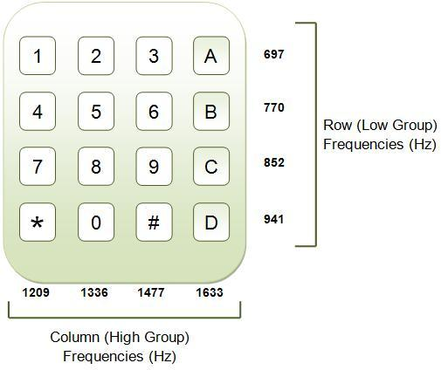

# need of dtmf decoding

# references

# references

# references

In the premature days, our telephone systems were operated by human operators in a telephone exchange room. The caller will pick up the phone, giving instruction to the operator to connect their line to the destination. It is a kind of manual switching. As more and more people entered in the telephone technology as useful communication gear, manual switching becomes a time consuming tedious task.

As technology established, pulse or dial tone technique was invented for telephone communication switching. It employs electronics and computer to support switching operations. DTMF (Dual Tone Multi Frequency) is the ultimate technique used in any of the Mobile, Telephone communication systems.

|  |  |  |  |  |  |  |
| --- | --- | --- | --- | --- | --- | --- |
| Button | Low DTMF frequency (Hz) | High DTMF frequency (Hz) | Binary coded output | | | |
| Q1 | Q2 | Q3 | Q4 |
| 1 | 697 | 1209 | 0 | 0 | 0 | 1 |
| 2 | 697 | 1336 | 0 | 0 | 1 | 0 |
| 3 | 697 | 1477 | 0 | 0 | 1 | 1 |
| 4 | 770 | 1209 | 0 | 1 | 0 | 0 |
| 5 | 770 | 1336 | 0 | 1 | 0 | 1 |
| 6 | 770 | 1477 | 0 | 1 | 1 | 0 |
| 7 | 852 | 1209 | 0 | 1 | 1 | 1 |
| 8 | 852 | 1336 | 1 | 0 | 0 | 0 |
| 9 | 852 | 1477 | 1 | 0 | 0 | 1 |
| 0 | 941 | 1336 | 1 | 0 | 1 | 0 |
| * | 941 | 1209 | 1 | 0 | 1 | 1 |
| # | 941 | 1477 | 1 | 1 | 0 | 0 |
| A | 697 | 1633 | 1 | 1 | 0 | 1 |
| B | 770 | 1633 | 1 | 1 | 1 | 0 |
| C | 852 | 1633 | 1 | 0 | 1 | 1 |
| D | 941 | 1633 | 1 | 1 | 1 | 1 |

# Block Diagram

# Circuit DiagramECG Features

# Circuit Diagram

# GROUP WORK

# Circuit DiagramECG Features

# Circuit DiagramECG Features

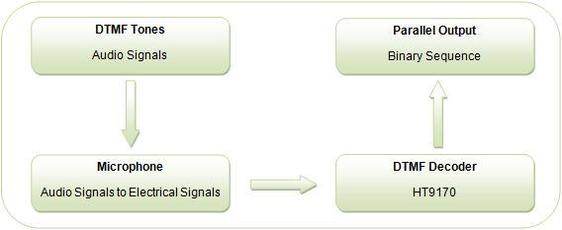

# DTMF GEneration

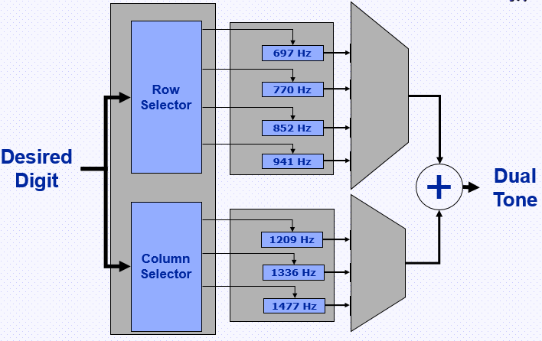

# DTMF Detection

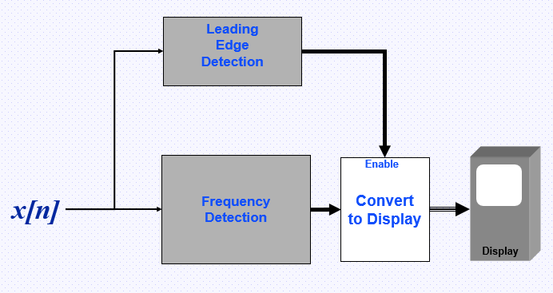

# Frequency generation

A DTMF keypad (generator or encoder) generates a sinusoidal tone which is mixture of the row and column frequencies. The row frequencies are low group frequencies. The column frequencies belong to high group frequencies. This prevents misinterpretation of the harmonics. Also, the frequencies for DTMF are so chosen that none have a harmonic relationship with the others and that mixing the frequencies would not produce sum or product frequencies that could mimic another valid tone. The high-group frequencies (the column tones) are slightly louder than the low-group to compensate for the high-frequency roll off of voice audio systems.

The row and column frequencies corresponding to a DTMF keypad have been indicated in the above figure.

DTMF tones are able to represent one of the 16 different states or symbols on the keypad. This is equivalent to 4 bits of data, also known as nibble.

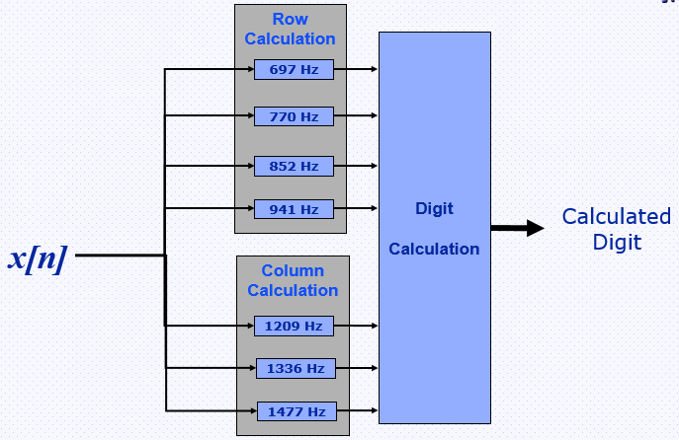

# APPLICATIONS

# CONCLUSION

# referencesRESULTS &CONCLUSION

# CONCLUSION

# RESULTS &CONCLUSION

# CONCLUSION

# referencesRESULTS &CONCLUSION

# CONCLUSION

* **DTMF Controlled Home Automation System :**

The main objective of this project is to implement home automation system for achieving the remote-control operation of home appliances using DTMF (Dual Tone Multi Frequency) technology.

* **DTMF Based Electronic Voting Machine:**

The main idea of this project is to replace the ballot paper type of voting system and make convenient form of electronic voting system by implementing a cell phone-based voting system using DTMF technology.

* **DTMF Based Effective Switching System for Power Efficiency:**

In this project, switching operation of various appliances in home and office are controlled in an effective way using DTMF decoder in the circuit. Along with DTMF decoder, microcontroller unit and GSM mobile facilitates this type of switching operation.

# Results & Conclusion

# references

# references

# referencesn

* FFT (Fast Fourier Transform) is the mathematical tool that can be used to calculate the frequency component in the given signal.
* DTMF technology was first introduced in telephone system in 1963 but nowadays it is used in different field of life.
* It reduces the waiting time, response time and increases the efficiency.
* The Dialer is now connected with the Receiver without the involvement of the third party person (Telephone Exchange).
* We can Reduce or Finish the theft rate, burglary and use DTMF in security Places (Military, Banks etc.), and can also use this technology in home automation systems.

# references

# references

# references

# references

[1]"DTMF - Genave", Genave, 2019. [Online]. Available: http://genave.com/dtmf/. [Accessed: 20- Jun- 2019]

[2]"Dual-tone multi-frequency signaling", En.wikipedia.org, 2019. [Online]. Available: https://en.wikipedia.org/wiki/Dual-tone_multi-frequency_signaling. [Accessed: 21- Jun- 2019]

[3]"What is Dual-Tone Multifrequency (DTMF) ? - Definition from Techopedia", Techopedia.com, 2019. [Online]. Available: https://www.techopedia.com/definition/26023/dual-tone-multifrequency-dtmf. [Accessed: 23- Jun- 2019]

[4]"What is DTMF (dual tone multi frequency)? - Definition from WhatIs.com", SearchNetworking, 2019. [Online]. Available: https://searchnetworking.techtarget.com/definition/DTMF. [Accessed: 23- Jun- 2019]

[5]2019. [Online]. Available: https://www.quora.com/What-is-DTMF-technology. [Accessed: 23- Jun- 2019]

[6]T. Agarwal, "Working Of DTMF (Dual Tone Multi Frequency) Technology and Its Applications", Buy Electronics & Electrical Projects in the United States, 2019. [Online]. Available: https://www.efxkits.us/dtmf-dual-tone-multi-frequency-technology-working-applications/. [Accessed: 22- Jun- 2019]

[7]"DTMF: Dual Tone Multi Frequency", Engineersgarage.com, 2019. [Online]. Available: https://www.engineersgarage.com/tutorials/dtmf-dual-tone-multiple-frequency. [Accessed: 21- Jun- 2019]